OBJECTIONS:-
What is objection?
An Objection is a communication in writing from a taxpayer to the Commissioner/Commissioner General expressing dissatisfaction with a tax decision within forty five days after receipt of notice of a tax decision.

An objection shall be in the prescribed form and shall state the grounds upon which it is made and must contain sufficient evidence to support it.

Who is required to do it?
A taxpayer who is dissatisfied with a tax decision issued by the authority
Why should one object?
a) To have a platform for a fair hearing regarding particular tax decision issued.
b) The objection process can facilitate issuance of an objection decision to an assessment by affirming ,reducing, increasing or otherwise varying the assessment the objection relates OR
In case of any tax decision by affirming, varying or setting aside the decision
What are the necessary requirements when objecting?
Where a taxpayer has lodged an objection to a tax assessment for a tax period, the commissioner may consider the objection if the taxpayer-
- Has furnished the return to which the assessment relates in the case of default or advance assessment.
- Has paid the tax due under the return to which the assessment relates together with any penalty or interest.

Can an objection decision be reviewed?
- A person dissatisfied with an objection decision may, within 30 days after being served with a notice of the objection decision, lodge an application with the Tax Appeals Tribunal for a review of the objection decision.
- A person dissatisfied with a decision of the Tribunal may, within 30days after being served with a notice of the decision, lodge an application with the High Court for review of the decision.

When am I required to lodge application for Objection Extension?
You are able to lodge applications for extension after the statutory due date to lodging the objection.
You are able to lodge multiple applications for extension; however the prior application must be closed (approved/rejected).

How is Extension of objection due date done?
You need to apply for extension of objection due date online.
To apply, Please visit the URA web portal, ura.go.ug and Login to your account with TIN and password.
Under e-services, select objection and appeals, select Extension of Due Date and fill in the required details then click on submit.
On successful submission, you will get an acknowledgement receipt with the reference number and search code. The communication will be sent to your email address after the application has been processed.

NB: Submit your application three days to the deadline to give the authority time to process your application.

After what period can I elect the Objection?
Please note that the System shall only allow election applications after expiry of the 90 days from date of submission of the objection.
However, you will not be able to submit an election application if you were requested for additional documents through eTAX.
What changes in the process of objection were brought by the TPC?
The changes in the objection process are provided for under section 24 of the Tax Procedures Code 2014.
A person who is dissatisfied with a tax decision may lodge an objection with the Commissioner within forty five days after receiving notice of the tax decision.
Taxpayer can submit his return through the objection process and if accepted will be treated as his self-assessment.
General objection processing rules implemented.
Removal of the 30 percent or amount not in dispute payment requirement for all tax types and the only conditions required for consideration of an objection are the ones listed below;
- Has the return to which the assessment relates in the case of a default or advance assessment been furnished.
- Has taxpayer paid the tax due under the return to which the assessment relates together with any penalty or interest due.
- Are the reasons/grounds for objection satisfactory?
The Commissioner shall serve notice of an objection decision on the person objecting within ninety days from the date of receipt of the objection for all Tax types.

Where a request for documents is made to the taxpayer, the obligation to make a decision within the statutory period (90 days) is no longer applicable. Therefore the system shall not allow the taxpayer to lodge an election application.

Where the Commissioner reviews the taxpayer records, the Commissioner shall notify the taxpayer of the review.
Taxpayer shall be able to lodge multiple applications for extension; however the prior application must be closed (approved/rejected).

How to file an objection with liability
-Go to https://ura.go.ug

Enter TIN, Password and click log in

-Under e-services select objections and appeals, and select objection with liability.
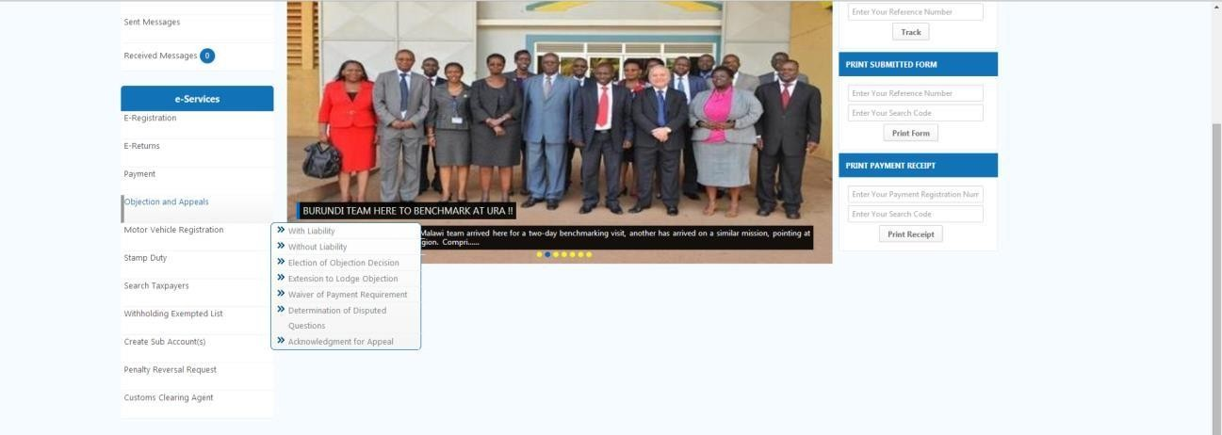

Select Objections with liability
-In put all mandatory details under objections with liability form, and click on next
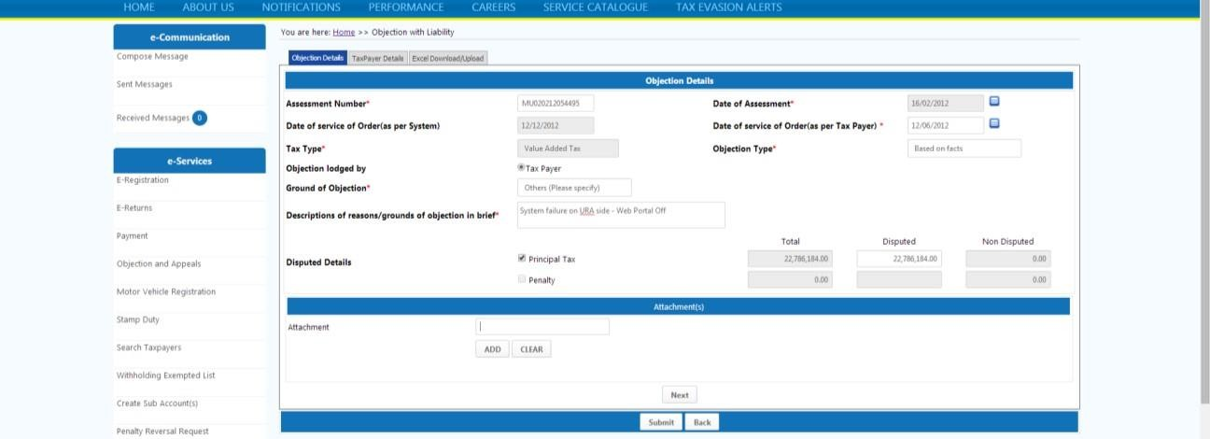

Click next.

-Down load the excel return from the third sheet
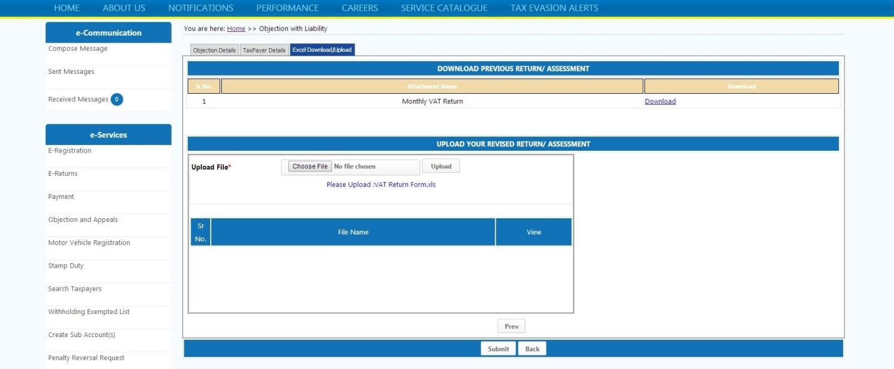

Click here

-On clicking on download another window will open up in a zipped folder, you have to click on the folder to get return template.
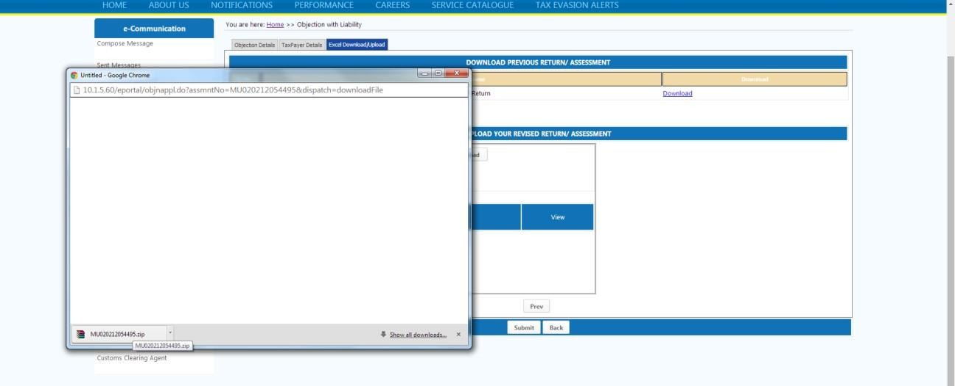

Click here

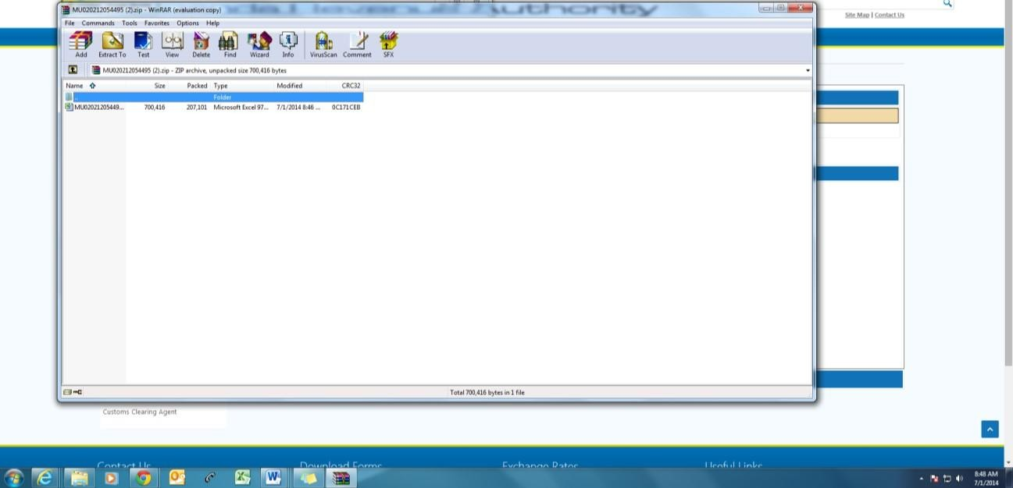

Click here to open the excel template
-Open the return template and make all the necessary changes, If you are objecting to the whole assessed amount select YES in order to file a nil return otherwise select NO and fill in the correct details in the respective schedules
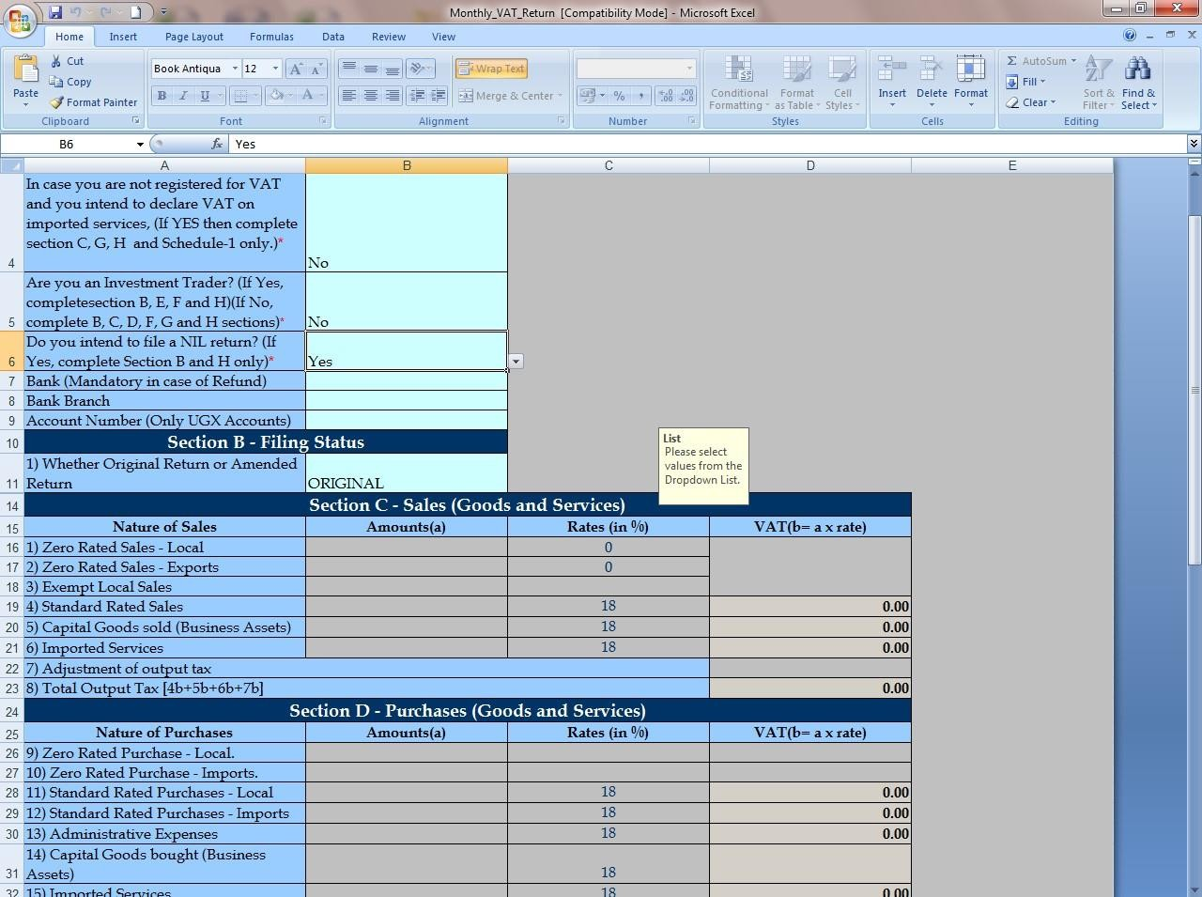
-Note: If an administrative assessment is issued due to non-filing of returns then at objection fill in your return the way it should have been.
-After making all necessary changes, validate to generate an upload file and save on the desired location.
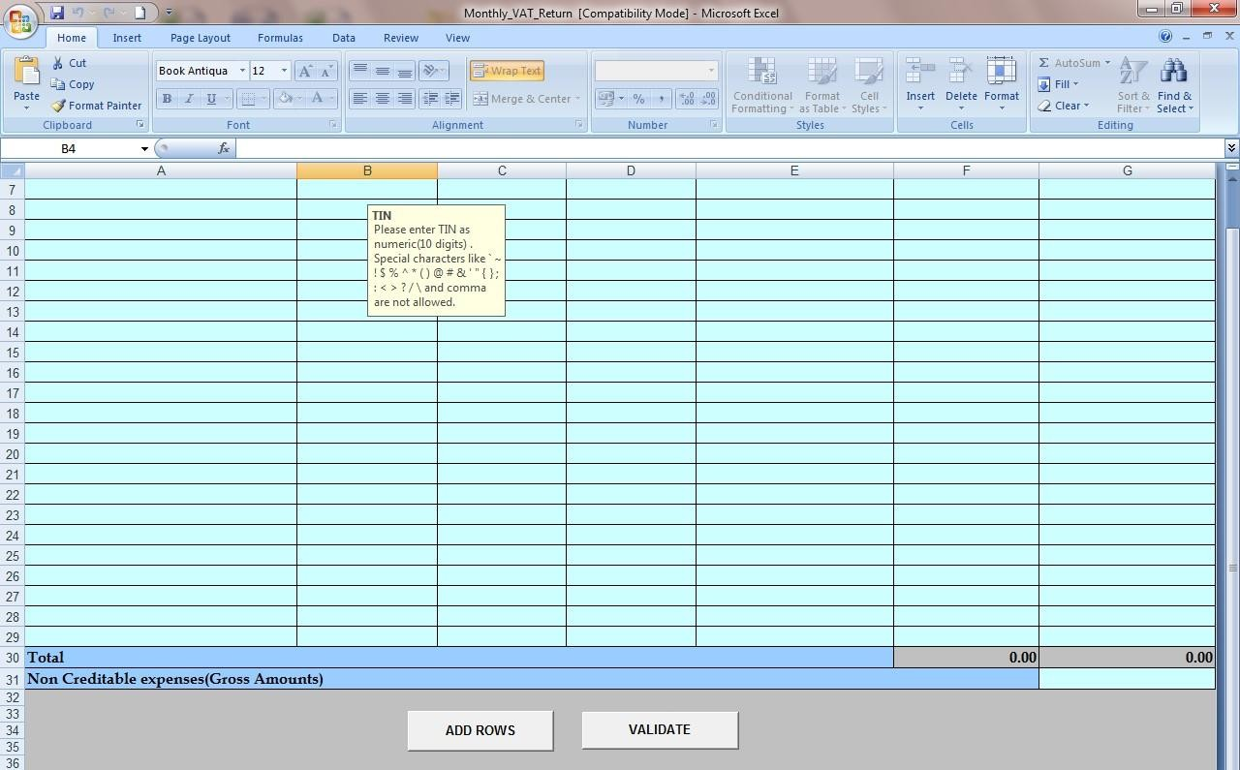

Click Validate
-Click on choose file to browse the upload file and upload.
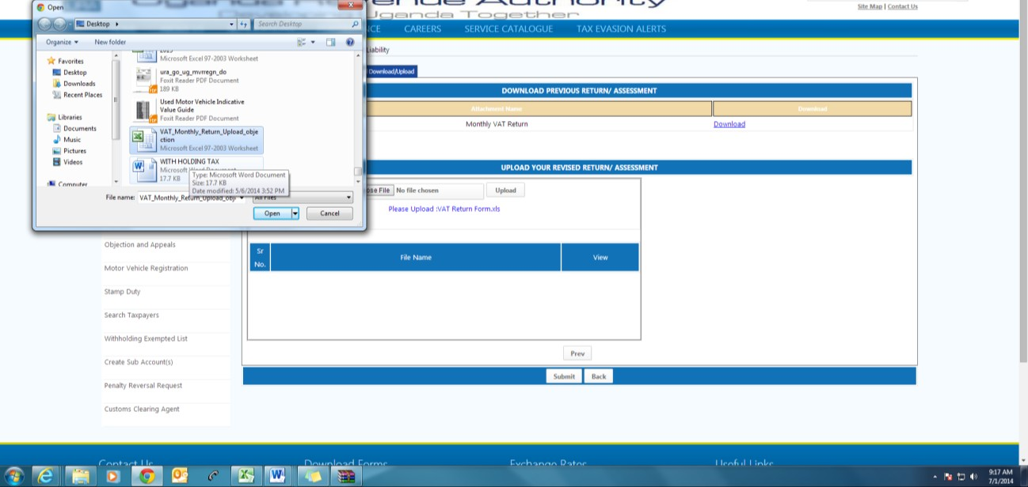

Click here

-After uploading the excel template click on SUBMIT.
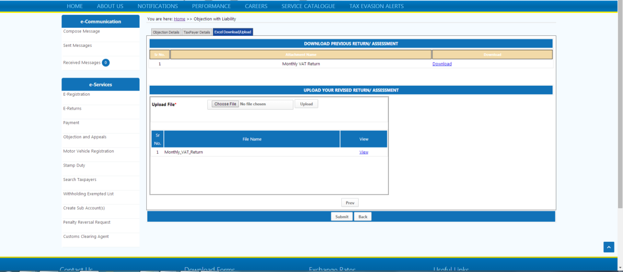

Click here to SUBMIT

On successful submission, you will get two acknowledgement receipts; one for objection and the other for the return submitted. Copies are also sent as received messages on your URA portal account.
You need to submit the acknowledgement receipt and the main form within 10 days to tax office.

How to file an objection without liability
When to choose Objection without Liability
This is used in scenarios where the taxpayer is objecting to any other decision which is not about a tax liability.
Go to https://ura.go.ug

Enter TIN, Password and click on log in

After logging in, click on Objection and Appeals and select OBJECTION WITHOUT LIABILITY
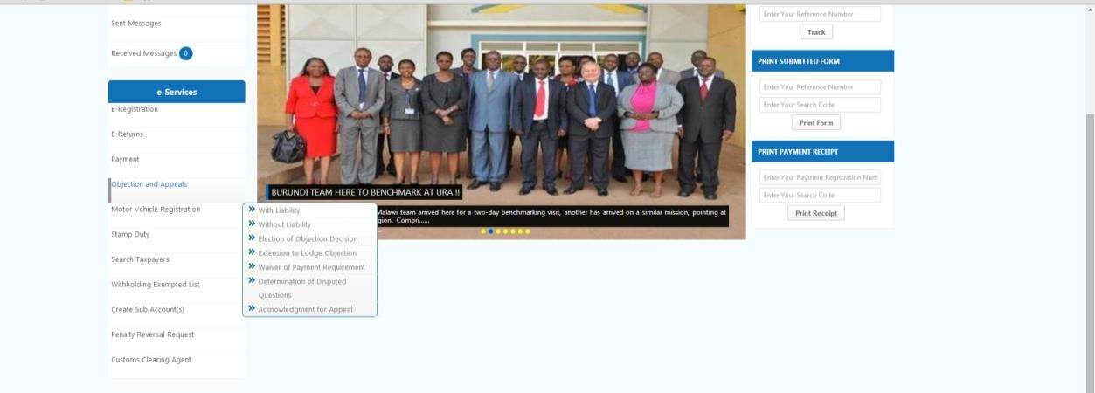

Click here

- Capture the notice number which you are objecting to, e.g a rejection notice.
- Indicate the date the notice was served on you, the tax type it relates to.
- Select the grounds for objection and describe in detail why you are objecting to the notice.
- Attach any supporting document in support of your objection.
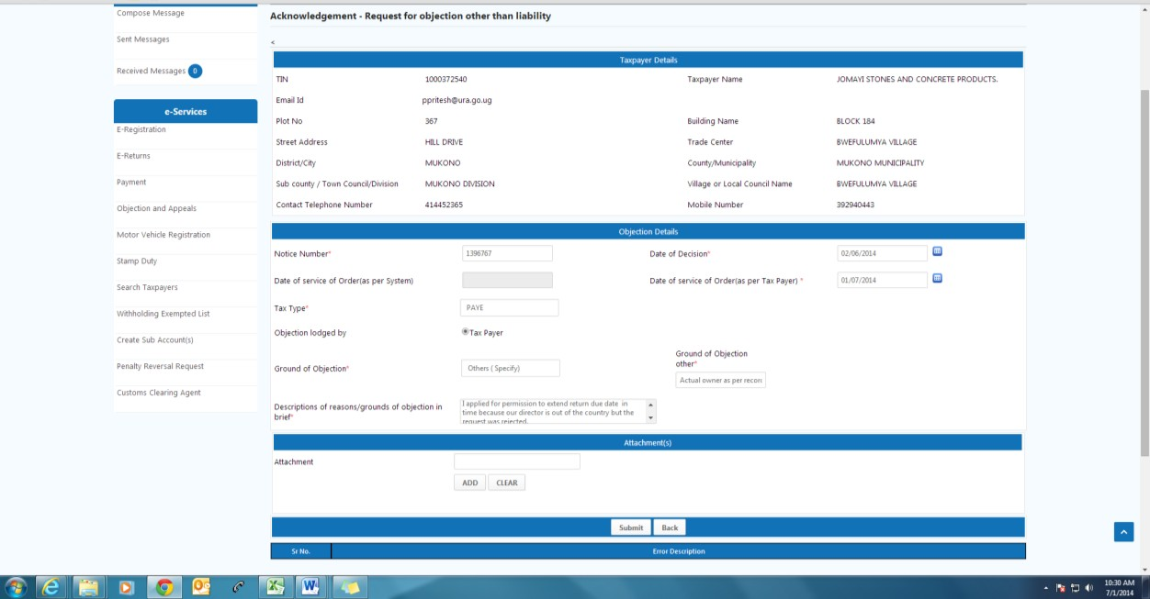
Click here to
submit
- Click on the submit button.
- An e-acknowledgment receipt will be generated.
- Click on the print button to print the acknowledgement receipt and form.

How to request for tax ruling and interpretation
​This is a process where a taxpayer initiates an enquiry for an interpretation of tax laws on the URA web portal. Such interpretations will depend on the tax rulings that were taken on the same case.
Go to https://ura.go.ug

Enter TIN, Password and click log in

Under your account click on objection and select Determination of disputed questions If the transaction has taken place select “YES”, if it has not taken place “NO”

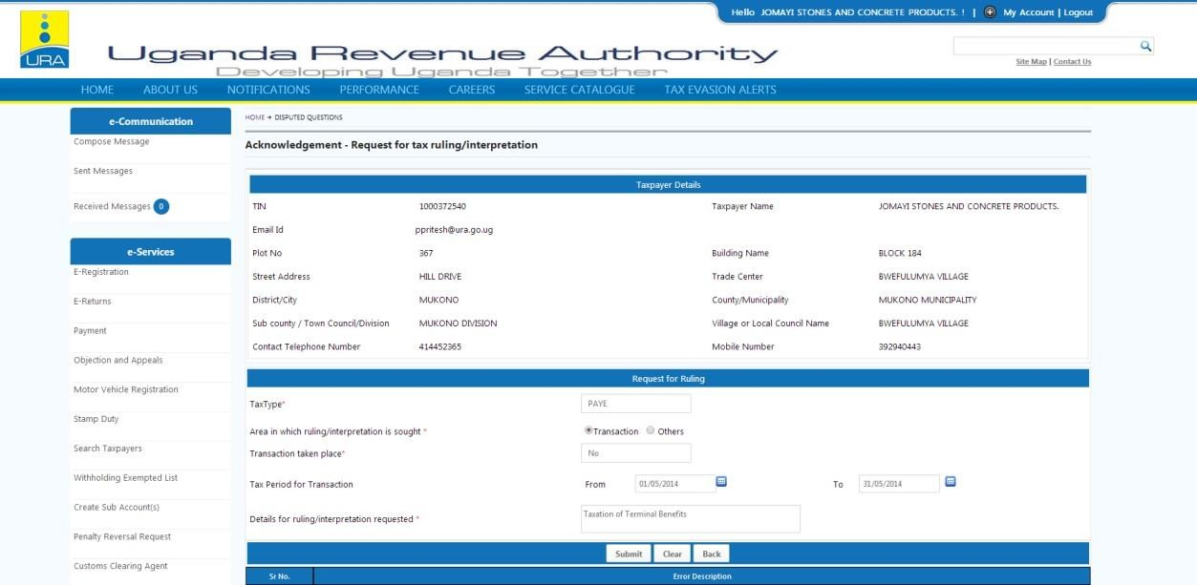
Click here to submit
Describe your reason
in detail.

