DIPLOMATIC VAT REFUND
​This is a process where Diplomats /Diplomatic missions claim a refund of money paid as VAT on all their expenses made in Uganda.
Such a refund is given to only the privileged persons and these include; Diplomats, Diplomatic missions e.g. embassies and entities listed in the first schedule of the VAT Act.
Expected Delivery Time
URA will acknowledge receipt of your refund application 'Instantly' upon submission and will notify you about your application status within 10 working days after receipt of all the necessary information and evidence for the refund.
Cost of the Service: FREE
REQUIREMENT
- Diplomats/ Diplomatic missions must show proof of VAT paid on all expenses and each individual expenditure should be exceeding 50,000/- Uganda Shillings.
- ​The total value of transactions for any claim period shall not be less than 200,000/= Uganda Shillings, excluding tax.
- The Organization/diplomatic mission must be listed in the First schedule to the VAT Act or must provide evidence of entitlement to relief in terms of a valid agreement with the government of Uganda.
- Diplomatic missions or accredited personnel may be required to provide evidence of entitlement to relief by producing the official card issued by the Ministry responsible for Foreign Affairs.
- The diplomatic mission or accredited personnel shall produce evidence of procurement and of payment of the tax. Supporting documents/records may include; File of original tax invoices and receipts
- Invoices & receipts generated by cash register machines shall be authenticated in form of a stamp from organization or embassy.
- Copy of identity card.

Step by step on how to apply for a Diplomatic VAT refund
PLEASE NOTE: The process for diplomatic refund starts by the diplomatic mission filling a diplomatic VAT return online using return template: DT-2032. (Follow step by step of filling a diplomatic return) The bank details are mandatory.
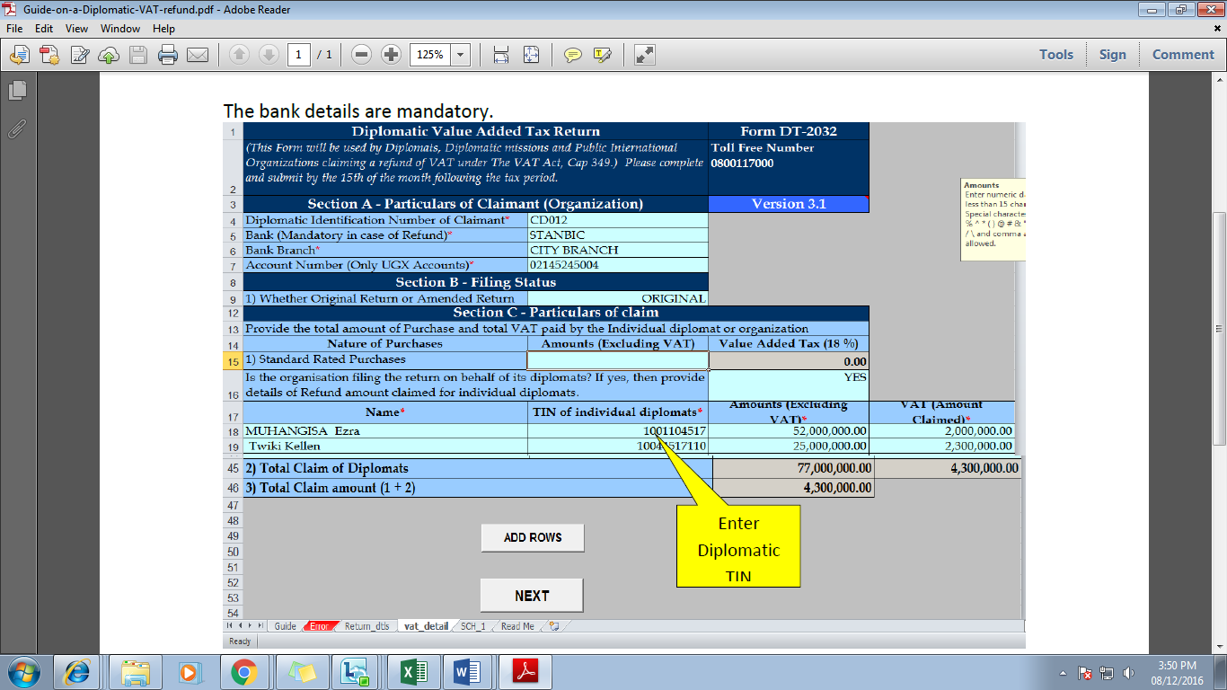
To be eligible for the refund the following requirements should be submitted to the office of jurisdiction;
- Printed forms for the return Submitted
- Original and duplicate invoices
- Copy of the diplomatic Identifications PLEASE NOTE: For a diplomat to be eligible for refund refer to the VAT act section 45 and regulations 7.

OTHER REFUNDS
- Double payments: - These refunds are a result of a taxpayer paying for a tax more than once. This can be due to: -
- mistake in registration of payment i.e. wrong figure, wrong TIN, wrong tax head, wrong name
- Double payments in customs duties i.e. two assessments
- Wrongful/erroneous withdrawal using third party agency notice e.g. from banks
- Registration of a wrong tax head i.e. excise duty instead of stamp duty
- Wrong customs assessments
- Exempt parties or organizations charged unknowingly
- Court rulings

For other tax types, the refund process is manual.
Apply for other refunds by downloading Form DT-3008 (visit the URA website, click on download manual forms<> domestic folder<> refund folder), print out and then manually fill it and deliver it to your tax office with the attach proof of payment.

Others types may include
- Stamp Duty
- Motor Vehicle
- Driving Permit
- Other NTR payments

The refund for these taxes will majorly occur when the tax payer has paid more taxes exceeding his tax liability.

