REFUNDS

What is a refund?
Refund is a repayment, reimbursement or compensation
- A tax refund is the difference between taxes paid and taxes owed. This may be as a result of taxes paid in error or in excess of tax assessed or due.

Refund Process
This is a process where a taxpayer claims money that was over paid to URA as tax.

Why you would apply for a Tax Refund
- The process provides you with an opportunity to use the refunded money to offset a tax liability for any other tax head.
- The refunded money can be used to increase the cash flow in your business operations.

Caution
- A refund of VAT and Local Excise can only be processed after filing the respective returns; whereas in the case of Income Tax and GPBT, you have to submit an application for a refund.
- Always provide original tax invoices for audit purposes for a first time application for a refund.

Please Note:
The following categories of taxpayers are entitled to VAT cash refunds because by virtue of their status no output tax is expected.

- An Investment trader may claim input tax deduction in respect of expenditure on inputs whether imported or locally procured, relating to the planned taxable business activities and that trader is entitled to a refund of the input tax on those purchases.

- Diplomatic missions, accredited personnel and public international organizations listed in the first schedule of the VAT Act, Cap 349, are also entitled to cash refunds.

What is the difference between a refund, a rebate and an offset
- Refund is a repayment, reimbursement or compensation
- Rebate is a discount, return or reduction (part refund)
- Offset is balance, counter balance or equalizer

Who qualifies for a refund?

  - ALL COMPLIANT TAXPAYERS.
  - Claims as a result of a decision of High court, TAT or Court of appeal

VAT REFUND

Circumstances under which VAT is refundable
- When input tax is greater than output tax
- When a tax payer pays more than what is supposed to be paid.
- When there is proven bad debt;
  - Should have been outstanding for at least 2 years and
  - Secondly, necessary steps should have been taken to recover the money to no vial
- When one loses the stock through fire, burglary and any other proven methods
- VAT refund to privileged persons. e.g diplomats and diplomatic missions. These must show proof of VAT paid and each individual expenditure should be exceeding 50,000.

The refund in case of monthly return is paid within thirty (30) days beyond which interest accrues.

INCOME TAX REFUND

Apply for any income tax (PAYE/Corporation tax) refund by visit the URA website, click on download manual forms<> domestic folder<> refund folder), print out and then manually fill it and deliver it to your tax office with the attach proof of payment.

Circumstances under which an income tax refund may occur
- When the tax payer has paid taxes exceeding his tax liability.
- Where his provisional tax paid is greater than the final tax assessed.
- Where the withholding tax paid is greater than his tax liability.

ORDINARY VAT REFUND

REQUIREMENT
Duly filled and signed Tax Refunds Return Form– DT – 2031. A taxpayer can only request for a refund if the amount is above 5 million Uganda shillings.

Please Note:
A VAT refund can be claimed through a provision included on the VAT return form.
- Where URA has delayed to process your tax refund without any justification, you are entitled to an interest on the refund amount of 2% per month simple interest for VAT. This commences from the end of the 30 working days during which the refund is processed.
- You must tick cash refund on the VAT form to claim the refund.
- A refund audit will be conducted if you are a first time applicant;
- If you are in a cash refundable position, the money will be deposited onto the declared bank account declared in URA;
- A person may claim a refund for the output tax paid in excess of the amount tax due for a tax period. This may arise as a result of :-
a) A taxable person’s input tax credit exceeding his or her output tax for that period, where he or she applies for a VAT refund through the monthly return
b) An objection decision
c) A decision of Tax Appeals Tribunal or High Court.
d) Loss of Goods in Stock, CG may grant a refund for the input tax paid on such goods.
e) Bad Debts, subject to S.43 (1)
f) Export / Zero rated goods
g) Purchases By Diplomats/diplomatic missions and international organizations.
However, where the amount of the excess input tax credit is less than 5 million, except for persons mainly dealing in zero rated supplies, CG shall offset that amount against the future liability of the taxable person.
The claim shall be made in a return within three years after the end of the tax period in which the tax was over paid.

Step by step guide for VAT Refund Process

Step 1:

Go to https://ura.go.ug


Enter TIN, pass word log in

Step 2:
Point on e-returns to select the type of return to be filed
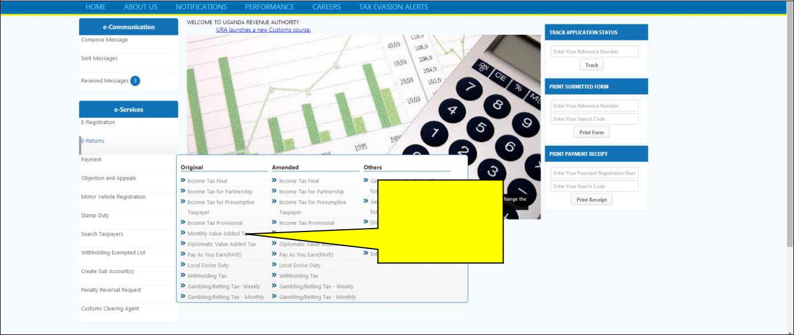

Select
VAT monthly return
Step 3:

Download the return template
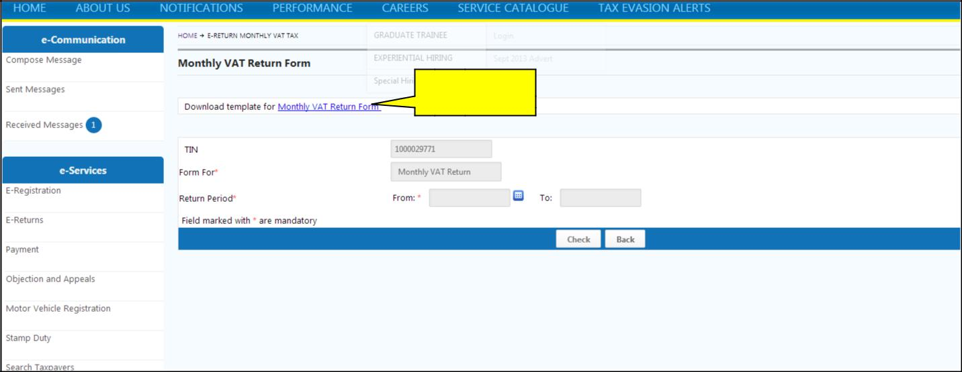

Click here

Step 4:

Save the template to your preferred location on your computer, you are not supposed to change the default file name, instead where it ends you can use space or an under score and provide your preferred name.
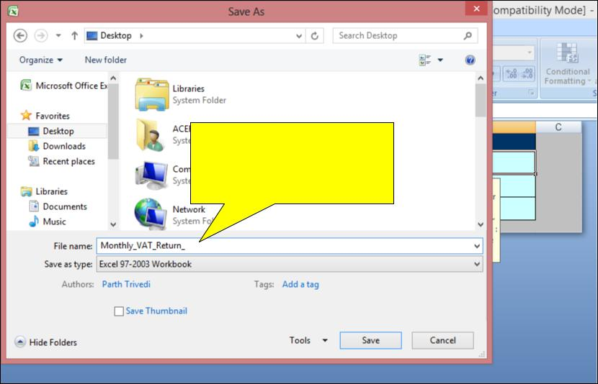

Add preferred file name

Step 5:

Open the template, before filling out the template; enable macros by following the instructions on the sheet labeled help, on the form you have downloaded, after enabling macros, close the file and open it again, you should get a pop up message that” Please DO NOT cut and paste any values in the sheet ”
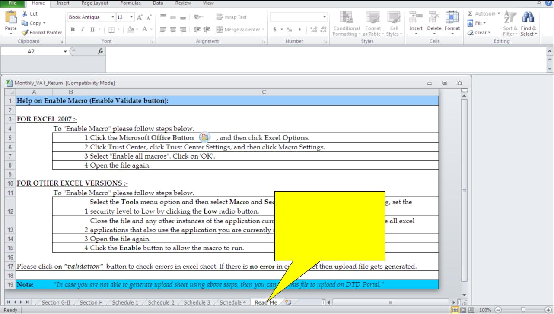

Make use of this guide to enable macros.

This is the pop up message you should get when you open a return template when the macros are enabled.
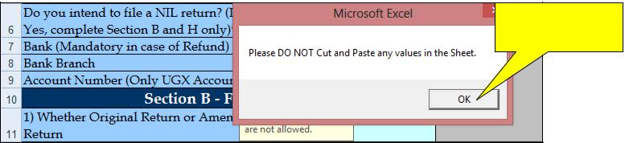
Click Ok

\

Step 6:

Fill in all the required details, and under Section H, select cash refund as below.

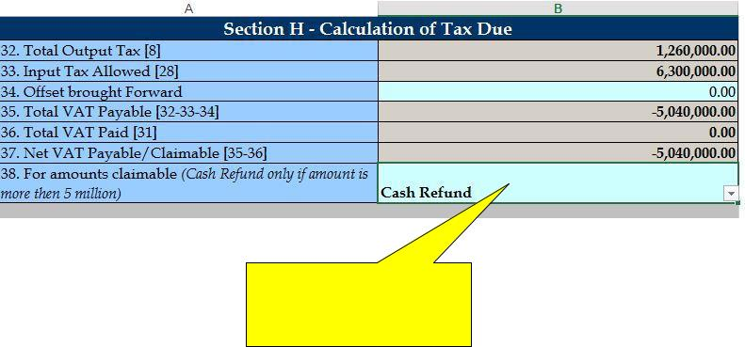

Select cash refund from down drop if your claim is 5million and above

After filling in all the required information, validate the form by clicking the VALIDATE button on the last page of the return.
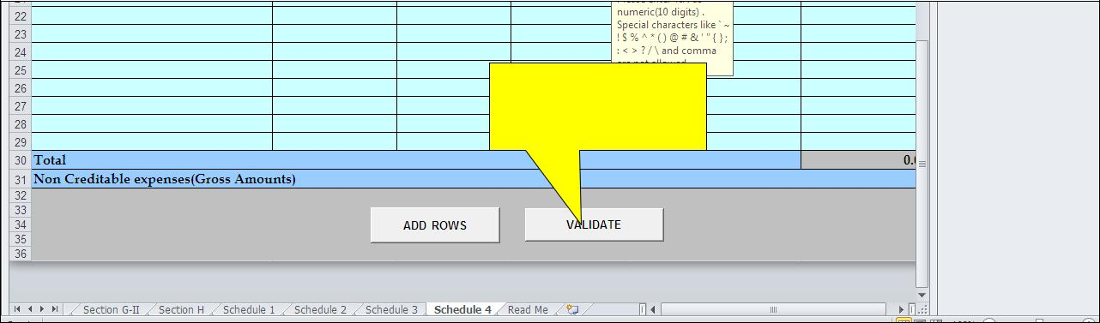

Click here to

Validate

In case of no errors, click on yes to generate an upload file, in case there are errors click on the error sheet, correct the errors, save and validate a gain, click on yes to generate an upload file
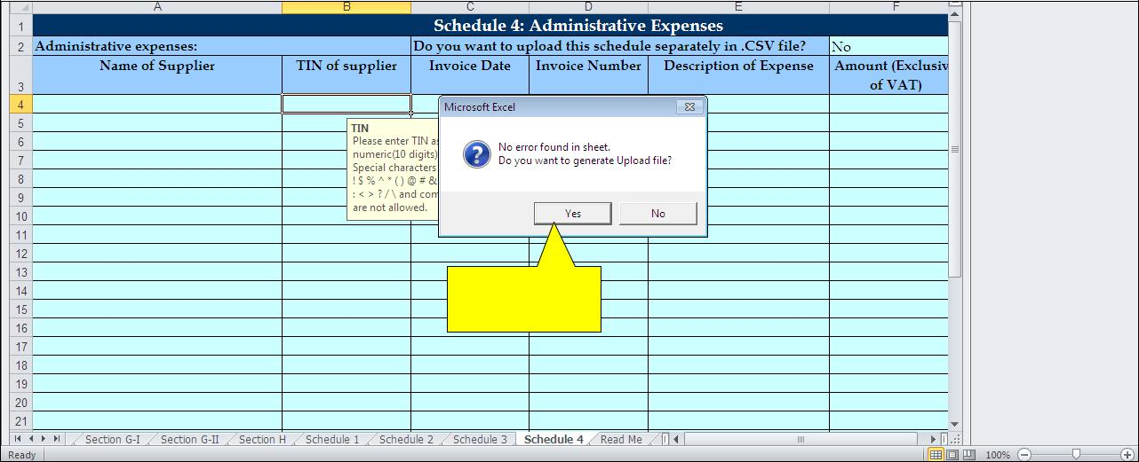

Click here

Save the uploaded version at the desired location.

It is better not to rename the upload file, when you are renaming, you are not supposed to leave space or use any unique character (`! $ %^*()@\&’”#;:{}/\) i.e.Monthly_VAT_Return02 or Monthly_VAT_Return_2014
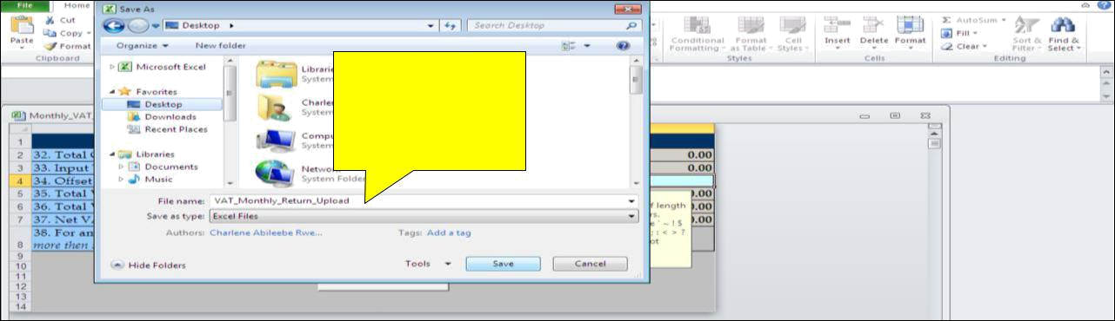

Add preferred file name.

Go back to the home page and log in to your account using TIN and pass word as seen below;
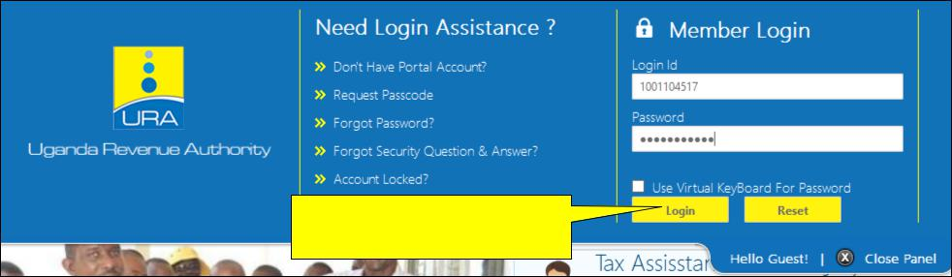

Enter TIN, pass word and log in.

After logging in, under e-services on left side, place your cursor on E-Returns and select the monthly VAT return.
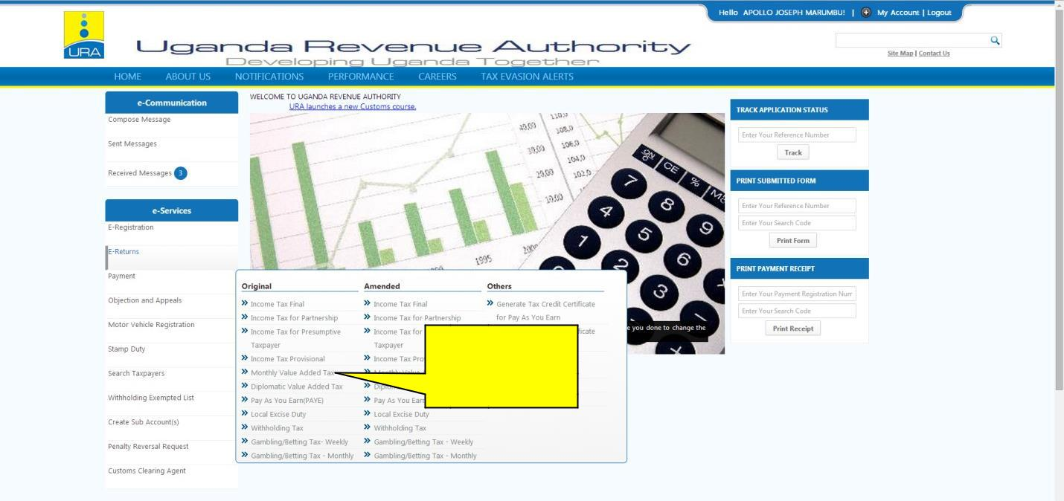

Select VAT return

Enter the period for which the return is being filed and click check.

Enter all the details required and Upload the return.

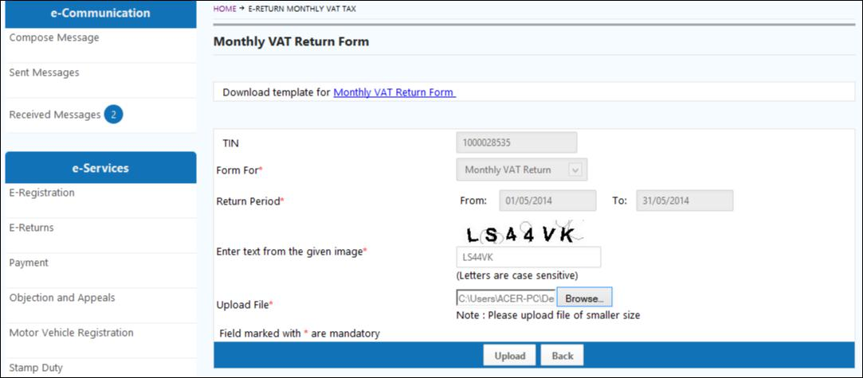
- If the form fails online validation, correct the specified errors on the saved template (from which you generated the upload file), save the file, validate and re-generate another upload file

If the upload is successful, click Submit, to submit your return.
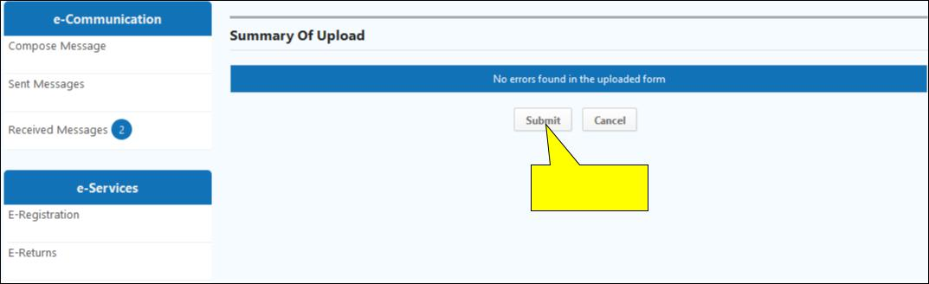

Click here

An e-Acknowledgement receipt will be generated and a copy sent to the email address provided at registration and the TIN account.

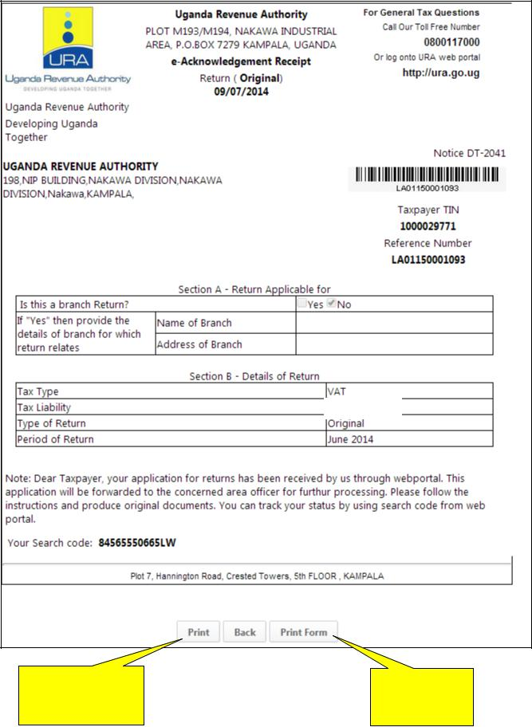

-5,040,000

Click to print | Click to print
Ackgnt receipt | submitted form

